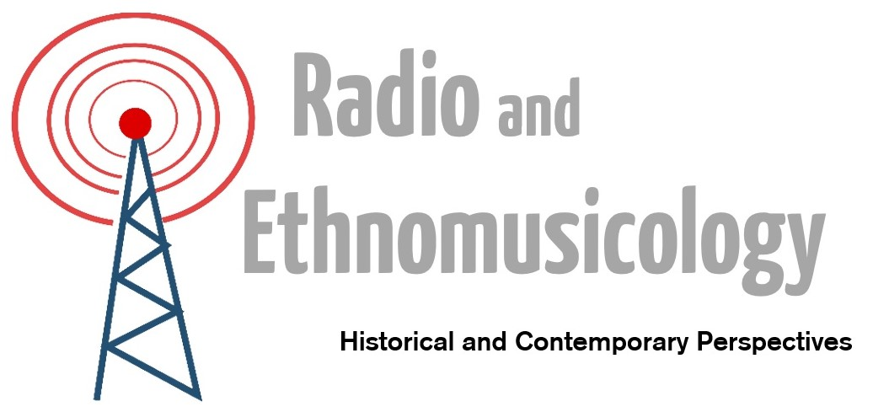
BFE One-Day Conference – Saturday 22 October, 2016
University of Edinburgh and the Museum of Communication, Scotland
Keynote: Timothy D. Taylor (UCLA)

Radio was one of the most important innovations of the 20th century, reconfiguring notions of intimacy, ushering in new forms of consumer economy, and playing a primary role in the rise of entertainment culture (Taylor 2012). At the same time, radio contributed to the democratisation of everyday life, reinvented a sense of national community, and created new communicative potentials for marginalised social groups (Scannell 1989). Politically, radio has been at the centre of global events such as the rise of National Socialism in Germany in the 1930s (Birdsall 2012), the Algerian Revolution (Fanon 1965), Cold War antagonism and cooperation (Badenoch et al 2013), and the Rwandan Genocide (Kellow and Steeves 1998). Across the world, it has been a tool of nation building, nationalism and internationalism, war and peace, sounding and silencing.
Despite proclamations of the death of radio (and television) in the 21st century, as a mode of broadcasting its contemporary importance has not diminished. Rather, broadcasters have migrated online, new digital listening forums have adopted techniques and practices from older media, and listening publics continue to be shaped by radio. Globalising and localising processes have been described as complementary rather than organised hierarchically (Appadurai 1996), with sounds and technologies made meaningful locally. Radio has adapted to the new technological forms and social logics of the digital era; it could therefore be argued that radio is as influential as ever.
It is a good time, then, to examine the relationships – both historical and contemporary – between radio and ethnomusicology. Within the discipline, radio has been heard in numerous ways: as a force of modernity that would destroy traditional music cultures; a means of circulating and developing respect for certain musics; a vehicle for musical scholarship; an accompaniment to musical migration and displacement; and a contact zone between music cultures. Moreover, radio broadcasters have frequently worked collaboratively with ethnomusicologists, commissioning, archiving and broadcasting field recordings (Davis 2005, Arnberg et al 1969, Reigle 2008). And radio serves as a productive site of ethnomusicological study today in its capacities as mediator, disseminator, and disciplinary mouthpiece.
Radio means different things in different times and places, and ethnomusicology is well equipped to provide form-sensitive and ethnographic accounts of its varying roles in musical and social life. This one-day conference seeks to explore these relationships by addressing themes including:
- Roles of radio in local and global music cultures
- The politics of music broadcasting
- Radio and musical mediation
- Availability and access to broadcast archives
- Broadcasting folk and world musics
- Radio, displacement and migration
- Digital broadcasting, web cultures, and ethnomusicology
- Histories of radio and fieldwork
- Nationalism, internationalism, and nation building
We invite proposals of individual papers of 20 minutes’ duration, or panels of 3 related papers. Abstracts should be no more than 300 words, and should be sent to radioethnomusicology@gmail.com by 5pm on Monday 2nd May. Notification of acceptance will be no later than 6th June. Please note that presenters must be registered members of the British Forum for Ethnomusicology (https://bfe.org.uk/join-bfe).
Conference Website: https://sites.eca.ed.ac.uk/radioethnomusicology/
DEADLINE for abstracts: 2nd May, 5pm.
Programme Committee:
Dr Annette Davison, Prof Simon Frith, Dr Mark Percival, Dr Tom Wagner, Dr Tom Western

